|  |
| --- |
| Macintosh HD:Users:Justin:Documents:Semester6:COMP397-WebGameProg:SporkAppsLogo.png |
| Slot Machine |
|  |
| Version #1  All work Copyright © 2015 by SporkApps  All rights reserved. |
| **Justin Caguiat** |
|  |

|  |
| --- |
| February 25, 2015 |

Table of Contents

Version History 3

Game Overview 4

Game Play Mechanics 4

Controls 4

Interface Sketch 5

Menu and Screen Descriptions 6

Start Screen 6

Jackpot Screen 7

Losing Screen 8

Scoring 9

Art / Multimedia Index 10

# Version History

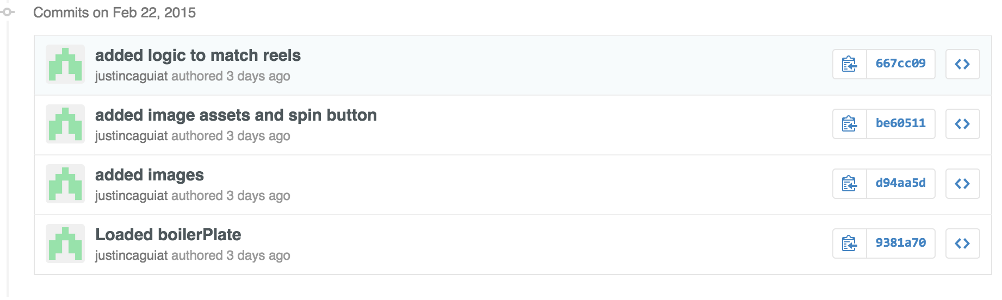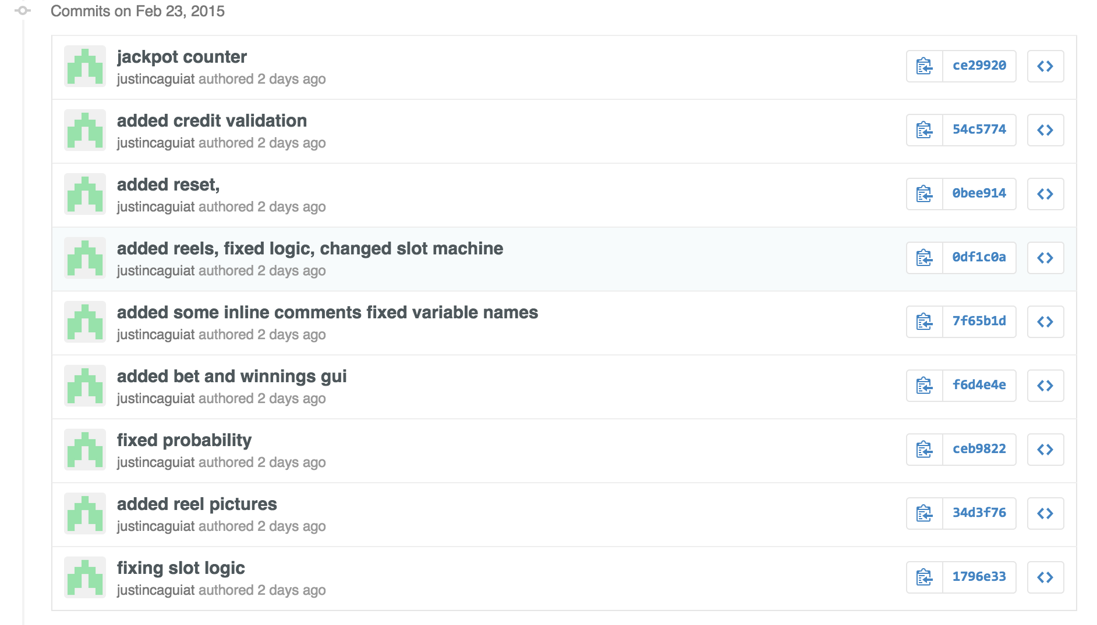

# Game Overview

The purpose of the slot machine is to have somebody bet money to win money. If the player matches 3 reels they will win a certain amount of credits based on a scoring system. If there are no matches, no credits will be awarded. Jackpot is awarded when 3 rings are spun.

# Game Play Mechanics

When the spin button is pressed 3 random reels are chosen from an array. Based on those choices it goes into a switch statement that calculates if there are any matches. After the matches are calculated it goes into the payout system and it calculates the amount to award the player; if any.

# Controls

The user uses the mouse to navigate the slot machine. They can click on various buttons to interact.

# Interface Sketch

# 

# Menu and Screen Descriptions

## Start Screen

## Jackpot ScreenLosing Screen**Scoring**

The player has the option to either bet 1, 10 or 50 credits.

The player will win credits back if the following conditions are met:

|  |  |
| --- | --- |
| Spin Results (with no blank reels) | Win Amount multiplier |
| Sonic x 3 | x10 |
| Tails x 3 | x20 |
| Super Sonic x 3 | x30 |
| Robotnic x3 | x40 |
| Bars x 3 | x50 |
| Knuckles x3 | x75 |
| Rings x3 | x100 + Jackpot amount |
| Sonic x2 | x2 |
| Tails x2 | x2 |
| Super Sonic x2 | x3 |
| Robotnic x2 | x4 |
| Bars x2 | x5 |
| Knuckles x2 | x10 |
| Rings x2 | x20 |
| no blank spaces | x1 |

If none of the conditions are met, the player does not win and credits back. When the player has 0 credits, they lose and have the option to reset the game.

# Art / Multimedia Index

